Wolfe Family

**of Pickaway and Ross Counties, Ohio**

*and related Worthen, Foster, List,*

*Fischer and Dresbach Family Lines*

Click here to go to Table of Contents

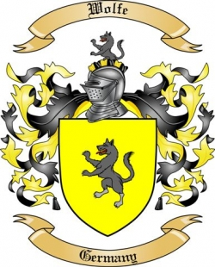

***A collaborative effort by:***

*Richard Edward Harrington – author*

*Mary Josephine Wolfe McCall – contributor*

*Elaine Katherine Moore– contributor*

*John Earl Wolfe - contributor*

*Judie Ann List Sweeney – contributor*

*Lois Anne Wolfe Harrington – contributor*

*Neil William Harrington – contributor*

*David and Carolyn Huffer List – contributor*

*Mark and Jeanette Chapman List – contributor*

*Renee Danielle Mettle – contributor*

*Diane Noreen Mettle Polczynski – contributor*

*Suzanne Kay Wolfe Mettle – contributor*

*Elaine Marie Johnson Bell – contributor*

*Laura Christine Johnson Cross – contributor*

*Joyce Elaine Wolfe Johnson - contributor*

|  |  |  |  |  |  |
| --- | --- | --- | --- | --- | --- |
| Crest - Dresbach Family Crest | Crest - Fischer Family Crest | Crest - Foster Family Crest | Crest - List Family Crest | Crest - Wolfe Family Crest | Crest - Worthen Family Crest |

Copyright: 1 December 2014

“**Wolfe Family of Pickaway and Ross Counties, Ohio**”



This book is part of a series of family tree books written to describe the genealogy of the author’s families.

Author and Publisher: Richard E. Harrington was the husband of Lois Anne Wolfe, daughter of Russell Franklin and Mary Helen Foster Wolfe. Many members of the Wolfe and extended family provided extensive valuable input for this book

Copyright: Under U.S. copyright law, the author of any copyrightable material is automatically granted a permanent copyright. For this book the copyright became effective on 1 December 2014. All rights are reserved.

The computer program, “Family Tree Maker,” was used for data storage and organization during the research and writing phases of this work. The Family Tree Maker book-writing feature was also used to help organize this book. While most of the material contained in this book was gathered by personal research, much credit is due to Ancestry.com for items such as online Federal Census.

*Richard E. Harrington*

*9517 Mount Vernon Landing*

*Alexandria, Virginia, USA*

*22309-3222*

Copyright: 1 December 2014

**i**

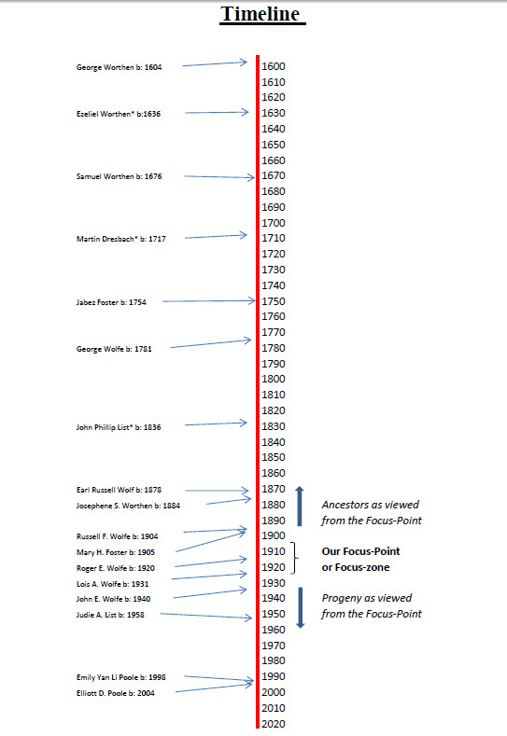

**ii**



**PREFACE**

Most of the family lines of the Wolfe and related families came to America in the early years of this Country. Most were farmers. Many fought in its wars. The primary countries of origin of these immigrants were Germany, England, Scotland and Ireland. They settled largely in the New England states and Pennsylvania. Eventually, branches of these early settlers moved to the Pickaway Plains of Ohio where they combined through marriage to become the families that are the subjects of this Book.

This book focuses primarily on the Wolfe line. Since genealogy is a study of the ancestors and descendants of a family line, in this book the Earl Russell and Josephine Sybil Worthen Wolfe family, including their four children, have been chosen as the focus on the Wolfe family timeline and the dividing point between ancestors and descendants. If this focus point appears to shift slightly sometimes, it is to allow the various charts, reports, etc. to more completely and unambiguously cover and address all of the family members.

This book is a collaborative effort of several of the Wolfe family descendants. Over the years these family-scribes have assiduously collected and maintained family pictures, records and data on their ever-changing branches. In early 2014 they agreed to contribute the fruits of their efforts to help populate this book.

**iii**

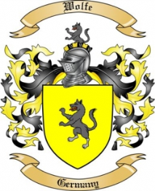

**HOW THIS BOOK IS ORGANIZED**

This book is primarily designed to tell the genealogical story of the Wolfe family that lived in Ross and Pickaway Counties, Ohio. The book includes 9 generations of Wolfes and covers a period of about 300 years. It is a large family that includes many different family lines.

It is not practical to include every branch of family that has contributed to making us who we are. The end product of such an effort would be too voluminous and would be almost impossible to follow. So this book focuses on a few of the families that lived in the 19th and 20th centuries and accounts for most of the progeny who are still living today. This group is defined by focusing on the Earl Russell Wolfe (1878-1955) branch of the Wolfe family, including his children. Earl, his wife, Josephine Sybil Worthen, and his children are gone. As this book is being written, Earl and Josephine’s grandchildren make up the senior living members of the family.

This book is organized by asking readers to position themselves on the timeline of the Wolfe and closely related families and gaze backwards in time at ancestors to whom we are indebted for our existence. Then, look forward in time into the future for a view of the progeny of the ongoing family.

The book opens by first carefully exploring the members of the Wolfe surname of the family. This Wolfe line is both the primary focus of the book and the line that is common to each of Earl and Josephine’s children; namely, Russell, Dorothy, Josephine and Roger Wolfe. The opening Pedigree Chart for Earl and Josephine’s son, Russell Franklin Wolfe, begins at our focus-point on the Wolfe family timeline. It provides perspective as we look back in time to the family ancestors. While the Pedigree Chart is specific for Russell Franklin Wolfe, it is the same Pedigree Chart for each of Earl and Josephine’s other three children; Russell’s siblings.

Thus begins our exploration of the Wolfe family tree. The details of the Wolfe family members are contained in the Wolfe Ahnentafel Report that follows the Wolfe Pedigree Chart. This report begins at our focus-point on the Wolfe timeline and moves back in time to our oldest known ancestor, Philip Wolfe, who was born in Bedford County, Pennsylvania in the year 1757.

For completeness, reference, and display of relationships of ancestors for the Wolfe line, an Outline Descendants Chart of the full Wolfe family follows. This Outline

**iv**

Descendants Chart begins with our oldest known Wolfe ancestor, Philip Wolfe born 1757 and moves forward in time to the present (2014). This chart contains the names and relevant data of all known Wolfe family tree members including the youngest progeny. It also includes some aunts, uncles and cousins not shown elsewhere in this book.

Equally important in the Wolfe family tree is the wife of Earl Wolfe, Josephine Sybil Worthen Wolfe. So a detailed Ahnentafel Report (the Worthen Ahnentafel Report) describes all we know about the Worthen family line, back to our oldest known ancestor, George Worthen (1604-1642), who was born and probably died in England.

This completes the ancestral presentation for the Wolfe line except for the all-important progeny of the Wolfe family. The progeny is presented as branches of Earl and Josephine’s children.

Following the above Wolfe family tree, four additional explorations are made; one for each of Earl and Josephine’s children. The Wolfe side of each of these children is covered by the Wolfe family line above and therefore not repeated. Each of the four explorations that correspond to one of Earl and Josephine’s children, begins with the familiar Pedigree Chart. This time the Pedigree Chart is for the spouse of an Earl and Josephine child providing an introduction to, and perspective for, that line. The Pedigree Chart is followed by an Ahnentafel Report for this same non-Wolfe spouse. This report provides all known details for this spouse’s family line.

To complete the exploration of each of Earl and Josephine’s children, a Descendants Chart is used that depicts the forward progress of the branch beginning with the Earl and Josephine child and their mate. This is followed by a Descendants Report that provides all known information on the branch, up to the date of publication of this book (2014).

Genealogy books are primarily reference books designed to capture the genealogical story of a family. This book contains a large amount of information. To make sure that the reader is able to locate people and information within the book, a comprehensive index is essential. Therefore, an index listing the many members of the family is located at the end of this book, but before the album. This index includes every part of the book except the album which is discussed below. The album has been excluded from the overall index because it has its own index.

An album of pictures and other graphics can be found at the end of the book. This album is the repository of all of the photos and other graphics referenced in the book. For example, references can be found within the Ahnentafel reports and elsewhere within the book. They are identified by the symbol, “***Photos in Album, Pages****:”* followed by the page-numbers within the album on which the picture can be found. In addition, a name index is located at the end of the album to help the reader locate photos within the album containing that person and the pages within the text of the book where the photo(s) of that person applies.

**v**

**Table of Contents**

Title Page ……………………………………......…… i

Timeline ….……………………………….….………. ii

Preface …...…………………………………………… iii

Organization of this Book ……………………….…… iv

Table of Contents (this page) ………………………… vi

About the Photo Album ………………………………… vii

Wolfe Line of Pickaway & Ross Counties …………… 1

Pedigree Chart of Wolfe line …………………..… 2

Wolfe Ancestors ……………………………….... 13

Descendants of Philip Wolfe …………………..… 33

Worthen Ancestors ………….…………….…….. 40

Descendants of George Worthen ………………... 56

Foster Line …………………………………………… 64

Pedigree Chart of Foster line ……………………. 65

Foster Ancestors ……………………………….... 75

Descendants of Benjamin Foster ………….…..… 97

Wolfe-Foster Descendants Chart ……………….. 100

Wolfe-Foster Descendants .…………………….. 110

List Line ……………………………………………. .. 137

Pedigree Chart of List line ……………………… 138

List Ancestors …………………………………… 139

Descendants of Adam List ……………………… 151

Wolfe-List Descendants Chart ………………….. 155

Wolfe-List Descendants .………………………... 166

Fischer Line …………………………………………… 188

Pedigree Chart of Fischer line …………………… 189

Fischer Ancestors ……………………………… 190

Dresbach Line ………………………………………… 196

Pedigree Chart of Dresbach line ………………… 197

Dresbach Ancestors ……………………………… 202

Descendants of Martin Dreisbach ……………… 232

Wolfe-Dresbach Descendants Chart …………… 238

Wolfe-Dresbach Descendants .………………… 239

Index ………………………………………………….. 250

Photo Album ………………………….… (at end of book) 257

**vi**

**Photo Album with Index**

“A picture is worth a thousand words.” That is never more true than when trying to describe people. So an effort has been made to include as many pictures of people in our ancestral lines as possible. At the end of this book is a Photo Album of at least one picture of each family member that we were able to find. Coverage is far from complete for many reasons. One major reason is that since commercially available photography was not available until about 1850, it came too late for many ancestors who died before the end of the 1800s. While the technology started to become publically available as early as about 1850, it took a couple more decades for equipment and photo supplies to become inexpensive enough to come into general use. Nevertheless, we were fortunate enough to find several photos of ancestors of the late 1800s.

One advantage of photos over the written text of the book is that since photos frequently capture people of several generations in one picture, they provide graphic interpretations of the life-spans and relationship of relatives. They are also the best source for comparisons of physical characteristics and family traits among individuals.

An index has been placed at the end of the Photo Album for the convenience of the reader. This index contains the name of every person included in the Album. Associated with each name is the page-number in the Album where the individual can be found. Also associated with each name is the page location in the book where the person can be found. To complete the cross reference between the book and the album, the page-numbers of photos of an individual are included, in blue, in the book at the primary point that that individual is discussed. This is the same page number that is located in the Photo Album index that references the individual’s location in the book. This is really simpler than it sounds and will become obvious once you check out the album index and the book text. It also helps the reader better appreciate the cliché about the shortcoming of a “thousand words” as compared to a picture. So, enjoy the pictures.

**vii**